Белорусский государственный технологический университет
Факультет информационных технологий
Кафедра программной инженерии

Лабораторная работа 3
По дисциплине «Основы Алгоритмизации И Программирования»
На тему «Динамические структуры данных. Односвязные списки»

Выполнил:
Студент 1 курса 6 группы
Качинскас Вацловас Вацловович
Преподаватель: асс. Андронова М.В.
2023, Минск

#include <iostream>
#include <fstream>
using namespace std;

struct Symbol
{
char symb;
Symbol* next;
};

const char menu[] = "\t1-input\n\t2-delete\n\t3-serch\n\t4-output\n\t5-save\n\t6-load\n\t0-exit\n";

void input(Symbol*& p, char symbol);
float del(Symbol*& p);
void serch(Symbol* p);
void output(Symbol* p);
void toF(Symbol* p);
void outF(Symbol*&p);

void main()
{
Symbol* plist = nullptr;
char switch_on = 1;
do
{
cout << menu << "input: ";
char switch_on;
cin >> switch_on;
switch (switch_on - '0')
{
case 1: input(plist, NULL);
break;
case 2: if (del(plist))
cout << "Succses!" << endl;
else
cout << "Err0r!" << endl;
break;
case 3: serch(plist);
break;
case 4:output(plist);
break;
case 5: toF(plist);
break;
case 6: outF(plist);
break;
case 0: break;
default: cout << '?' << endl;
break;
}
} while (switch_on != '0');
}

//Input symbol
void input(Symbol *&p, char symbol) {
if (symbol == NULL) {
cout << "Input symbol: ";
cin >> symbol;
}
Symbol* newP = new Symbol;
if (newP != NULL)
{
newP->symb = symbol;
newP->next = p;
p = newP;
}
else
cout << "Err0r" << endl;

}

//Delete symbol
float del(Symbol*& p) {
char value;
cout << "Input symbol: ";
cin >> value;
Symbol* previous, * current, * temp;
if (value == p->symb)
{
temp = p;
p = p->next; // отсоединить узел
delete temp; //освободить отсоединенный узел
return value;
}
else
{
previous = p;
current = p->next;
while (current != NULL && current->symb != value)
{
previous = current;
current = current->next; // перейти к следующему
}
if (current != NULL)
{
temp = current;
previous->next = current->next;
delete(temp);
return value;
}
}
return 0;
}

//Serch symbol
void serch(Symbol* p) {
cout << "Input searched symbol: ";
char c;
cin >> c;
while (p) // перебор списка
{
if (p->symb == c) {
cout << p->symb << " + ";
p = p->next;
cout << p->symb << endl;
break;
}
p = p->next;
}
}

//Output list of symbols
void output(Symbol* p) {
if (p == NULL)
cout << "Is empty:(" << endl;
else
{
if (p != nullptr)
while (p != NULL)
{
cout << "-->" << p->symb;
p = p->next;
}
cout << "-->(END)" << endl;
}

}

//Into File
void toF(Symbol* p) {
Symbol* temp = p;
Symbol buf;
ofstream Tofil("base.koi");
if (Tofil.fail())
{
cout << endl << "Err0r" << endl;
return;
}
while (temp != NULL)
{
buf = *temp;
Tofil.write((char*)&buf, sizeof(Symbol));
temp = temp->next;
}
Tofil.close();
cout << "Success!" << endl;
}

//Outto File
void outF(Symbol*&p) {
Symbol buf;
ifstream outFil("base.koi");
if (outFil.fail())
{
cout << endl << "Err0r" << endl;
return;
}
outFil.read((char*)&buf, sizeof(Symbol));
while (!outFil.eof())
{
input(p, buf.symb);
cout << "-->" << buf.symb;
outFil.read((char*)&buf, sizeof(Symbol));
}
cout << "-->(END)" << endl;
outFil.close();
cout << "Success!" << endl;
}
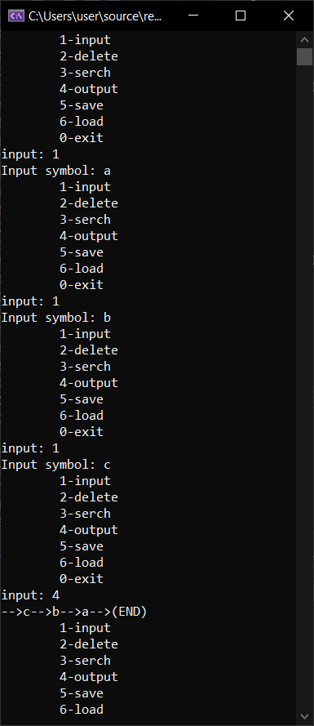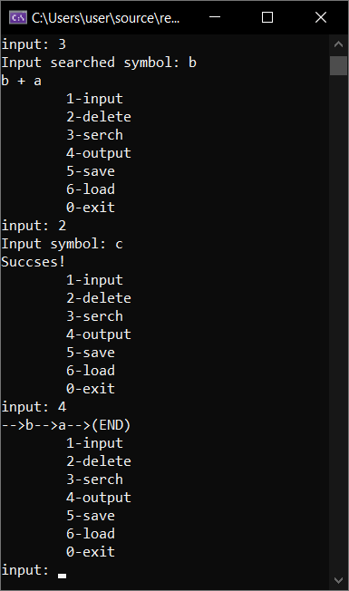
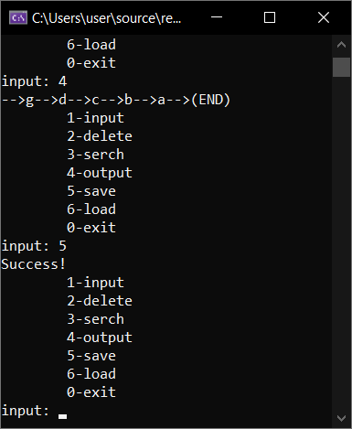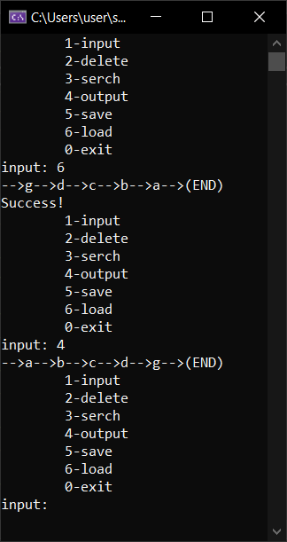

#include <iostream>
#include <fstream>
using namespace std;

struct Symbol
{
int symb;
Symbol* next;
};

const char menu[] = "\t1-input\n\t2-delete\n\t3-serch\n\t4-output\n\t5-save\n\t6-load\n\t7-do task\n\t0-exit\n";

void input(Symbol*& p, int symbol);
float del(Symbol*& p);
void serch(Symbol* p);
void output(Symbol* p);
void toF(Symbol* p);
void outF(Symbol*&p);
void task(Symbol* p);

void main()
{
Symbol* plist = nullptr;
char switch_on = 1;
do
{
cout << menu << "input: ";
char switch_on;
cin >> switch_on;
switch (switch_on - '0')
{
case 1: input(plist, NULL);
break;
case 2: if (del(plist))
cout << "Succses!" << endl;
else
cout << "Err0r!" << endl;
break;
case 3: serch(plist);
break;
case 4:output(plist);
break;
case 5: toF(plist);
break;
case 6: outF(plist);
break;
case 7: task(plist);
break;
case 0: break;
default: cout << '?' << endl;
break;
}
} while (switch_on != '0');
}

//Input symbol
void input(Symbol *&p, int symbol) {
if (symbol == NULL) {
cout << "Input symbol: ";
cin >> symbol;
}
Symbol* newP = new Symbol;
if (newP != NULL)
{
newP->symb = symbol;
newP->next = p;
p = newP;
}
else
cout << "Err0r" << endl;

}

//Delete symbol
float del(Symbol*& p) {
char value;
cout << "Input symbol: ";
cin >> value;
Symbol* previous, * current, * temp;
if (value == p->symb)
{
temp = p;
p = p->next; // отсоединить узел
delete temp; //освободить отсоединенный узел
return value;
}
else
{
previous = p;
current = p->next;
while (current != NULL && current->symb != value)
{
previous = current;
current = current->next; // перейти к следующему
}
if (current != NULL)
{
temp = current;
previous->next = current->next;
delete(temp);
return value;
}
}
return 0;
}

//Serch symbol
void serch(Symbol* p) {
cout << "Input searched symbol: ";
char c;
cin >> c;
while (p) // перебор списка
{
if (p->symb == c) {
cout << p->symb << " + ";
p = p->next;
cout << p->symb << endl;
break;
}
p = p->next;
}
}

//Output list of symbols
void output(Symbol* p) {
if (p == NULL)
cout << "Is empty:(" << endl;
else
{
if (p != nullptr)
while (p != NULL)
{
cout << "-->" << p->symb;
p = p->next;
}
cout << "-->(END)" << endl;
}

}

//Into File
void toF(Symbol* p) {
Symbol* temp = p;
Symbol buf;
ofstream Tofil("base.koi");
if (Tofil.fail())
{
cout << endl << "Err0r" << endl;
return;
}
while (temp != NULL)
{
buf = *temp;
Tofil.write((char*)&buf, sizeof(Symbol));
temp = temp->next;
}
Tofil.close();
cout << "Success!" << endl;
}

//Outto File
void outF(Symbol*&p) {
Symbol buf;
ifstream outFil("base.koi");
if (outFil.fail())
{
cout << endl << "Err0r" << endl;
return;
}
outFil.read((char*)&buf, sizeof(Symbol));
while (!outFil.eof())
{
input(p, buf.symb);
cout << "-->" << buf.symb;
outFil.read((char*)&buf, sizeof(Symbol));
}
cout << "-->(END)" << endl;
outFil.close();
cout << "Success!" << endl;
}

void task(Symbol* p) {
if (p == NULL)
cout << "Is empty:(" << endl;
else
{
int sum = 0;
if (p != nullptr)
while (p != NULL)
{
if (p->symb > 0)
sum += p->symb;
p = p->next;
}
if (sum != 0)
cout << "Answer: " << sum << endl;
else
cout << "nuh uh!";
}
}
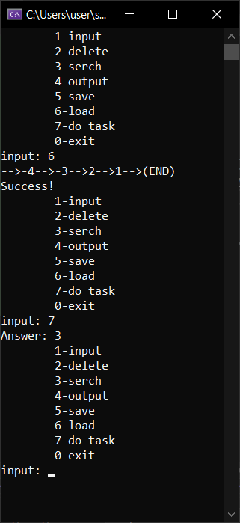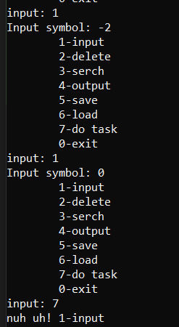
#include <iostream>
#include <fstream>
using namespace std;

typedef float fortask;

struct Symbol
{
fortask symb;
Symbol* next;
};

const char menu[] = "\t1-input\n\t2-delete\n\t3-serch\n\t4-output\n\t5-save\n\t6-load\n\t7-do task\n\t0-exit\n";

void input(Symbol*& p, fortask symbol);
float del(Symbol*& p);
void serch(Symbol* p);
void output(Symbol* p);
void toF(Symbol* p);
void outF(Symbol*&p);
void task(Symbol* p);

void main()
{
Symbol* plist = nullptr;
char switch_on = 1;
do
{
cout << menu << "input: ";
char switch_on;
cin >> switch_on;
switch (switch_on - '0')
{
case 1: input(plist, NULL);
break;
case 2: if (del(plist))
cout << "Succses!" << endl;
else
cout << "Err0r!" << endl;
break;
case 3: serch(plist);
break;
case 4:output(plist);
break;
case 5: toF(plist);
break;
case 6: outF(plist);
break;
case 7: task(plist);
break;
case 0: break;
default: cout << '?' << endl;
break;
}
} while (switch_on != '0');
}

//Input symbol
void input(Symbol *&p, fortask symbol) {
if (symbol == NULL) {
cout << "Input symbol: ";
cin >> symbol;
}
Symbol* newP = new Symbol;
if (newP != NULL)
{
newP->symb = symbol;
newP->next = p;
p = newP;
}
else
cout << "Err0r" << endl;

}

//Delete symbol
float del(Symbol*& p) {
char value;
cout << "Input symbol: ";
cin >> value;
Symbol* previous, * current, * temp;
if (value == p->symb)
{
temp = p;
p = p->next; // отсоединить узел
delete temp; //освободить отсоединенный узел
return value;
}
else
{
previous = p;
current = p->next;
while (current != NULL && current->symb != value)
{
previous = current;
current = current->next; // перейти к следующему
}
if (current != NULL)
{
temp = current;
previous->next = current->next;
delete(temp);
return value;
}
}
return 0;
}

//Serch symbol
void serch(Symbol* p) {
cout << "Input searched symbol: ";
char c;
cin >> c;
while (p) // перебор списка
{
if (p->symb == c) {
cout << p->symb << " + ";
p = p->next;
cout << p->symb << endl;
break;
}
p = p->next;
}
}

//Output list of symbols
void output(Symbol* p) {
if (p == NULL)
cout << "Is empty:(" << endl;
else
{
if (p != nullptr)
while (p != NULL)
{
cout << "-->" << p->symb;
p = p->next;
}
cout << "-->(END)" << endl;
}

}

//Into File
void toF(Symbol* p) {
Symbol* temp = p;
Symbol buf;
ofstream Tofil("base.koi");
if (Tofil.fail())
{
cout << endl << "Err0r" << endl;
return;
}
while (temp != NULL)
{
buf = *temp;
Tofil.write((char*)&buf, sizeof(Symbol));
temp = temp->next;
}
Tofil.close();
cout << "Success!" << endl;
}

//Outto File
void outF(Symbol*&p) {
Symbol buf;
ifstream outFil("base.koi");
if (outFil.fail())
{
cout << endl << "Err0r" << endl;
return;
}
outFil.read((char*)&buf, sizeof(Symbol));
while (!outFil.eof())
{
input(p, buf.symb);
cout << "-->" << buf.symb;
outFil.read((char*)&buf, sizeof(Symbol));
}
cout << "-->(END)" << endl;
outFil.close();
cout << "Success!" << endl;
}

void task(Symbol* p) {
if (p == NULL)
cout << "Is empty:(" << endl;
else
{
fortask sum = 0, cnt = 0;
if (p != nullptr)
while (p != NULL)
{
if (p->symb > 0) {
sum += p->symb; cnt++;
}
p = p->next;
}
if (sum != 0)
cout << "Answer: " << sum / cnt << endl;
else
cout << "nuh uh!";
}
}

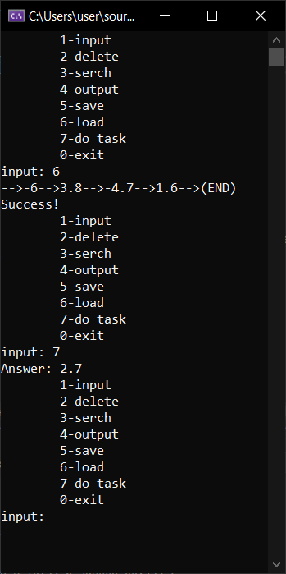
#include <iostream>
#include <fstream>
using namespace std;

typedef int fortask;

struct Symbol
{
fortask symb;
Symbol* next;
};

const char menu[] = "\t1-input\n\t2-delete\n\t3-serch\n\t4-output\n\t5-save\n\t6-load\n\t7-do task\n\t0-exit\n";

void input(Symbol*& p, fortask symbol);
float del(Symbol*& p);
void serch(Symbol* p);
void output(Symbol* p);
void toF(Symbol* p);
void outF(Symbol*&p);
void task(Symbol* p);

void main()
{
Symbol* plist = nullptr;
char switch_on;
do
{
cout << menu << "input: ";
cin >> switch_on;
char forwhile = switch_on - '0';
switch (switch_on - '0')
{
case 1: input(plist, NULL);
break;
case 2: if (del(plist))
cout << "Succses!" << endl;
else
cout << "Err0r!" << endl;
break;
case 3: serch(plist);
break;
case 4:output(plist);
break;
case 5: toF(plist);
break;
case 6: outF(plist);
break;
case 7: task(plist);
break;
case 0: break;
default: cout << '?' << endl;
break;
}
} while (switch_on != '0');
}

//Input symbol
void input(Symbol *&p, fortask symbol) {
if (symbol == NULL) {
cout << "Input symbol: ";
cin >> symbol;
}
Symbol* newP = new Symbol;
if (newP != NULL)
{
newP->symb = symbol;
newP->next = p;
p = newP;
}
else
cout << "Err0r" << endl;

}

//Delete symbol
float del(Symbol*& p) {
char value;
cout << "Input symbol: ";
cin >> value;
Symbol* previous, * current, * temp;
if (value == p->symb)
{
temp = p;
p = p->next; // отсоединить узел
delete temp; //освободить отсоединенный узел
return value;
}
else
{
previous = p;
current = p->next;
while (current != NULL && current->symb != value)
{
previous = current;
current = current->next; // перейти к следующему
}
if (current != NULL)
{
temp = current;
previous->next = current->next;
delete(temp);
return value;
}
}
return 0;
}

//Serch symbol
void serch(Symbol* p) {
cout << "Input searched symbol: ";
char c;
cin >> c;
while (p) // перебор списка
{
if (p->symb == c) {
cout << p->symb << " + ";
p = p->next;
cout << p->symb << endl;
break;
}
p = p->next;
}
}

//Output list of symbols
void output(Symbol* p) {
if (p == NULL)
cout << "Is empty:(" << endl;
else
{
if (p != nullptr)
while (p != NULL)
{
cout << "-->" << p->symb;
p = p->next;
}
cout << "-->(END)" << endl;
}

}

//Into File
void toF(Symbol* p) {
Symbol* temp = p;
Symbol buf;
ofstream Tofil("base.koi");
if (Tofil.fail())
{
cout << endl << "Err0r" << endl;
return;
}
while (temp != NULL)
{
buf = *temp;
Tofil.write((char*)&buf, sizeof(Symbol));
temp = temp->next;
}
Tofil.close();
cout << "Success!" << endl;
}

//Outto File
void outF(Symbol*&p) {
Symbol buf;
ifstream outFil("base.koi");
if (outFil.fail())
{
cout << endl << "Err0r" << endl;
return;
}
outFil.read((char*)&buf, sizeof(Symbol));
while (!outFil.eof())
{
input(p, buf.symb);
cout << "-->" << buf.symb;
outFil.read((char*)&buf, sizeof(Symbol));
}
cout << "-->(END)" << endl;
outFil.close();
cout << "Success!" << endl;
}

void task(Symbol* p) {
if (p == NULL)
cout << "Is empty:(" << endl;
else
{
fortask sum = 0;
if (p != nullptr)
while (p != NULL)
{
if (p->symb > 0 && !(p->symb % 5)) {
sum += p->symb;
}
p = p->next;
}
if (sum != 0)
cout << "Answer: " << sum << endl;
else
cout << "nuh uh!";
}
}
